CS 223

DIGITAL DESIGN AND COMPUTER ARCHITECTURE

PROJECT REPORT

YASEMİN AKIN

22101782

19 DECEMBER 2022

b) RTL schematics for Ascending and Descending Sorting operations

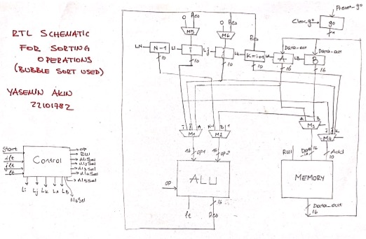

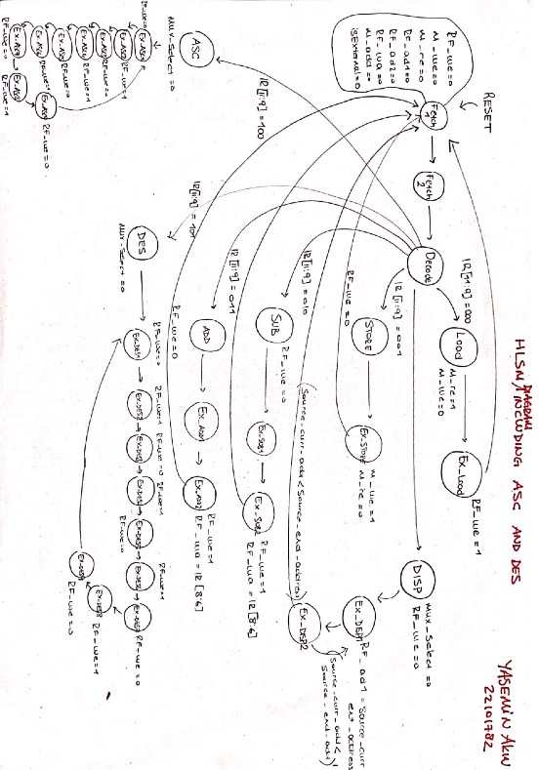c) Controller High-Level State Machine Diagram

(including ascending and descending sorting operations 🡪 I could not implement this yet so I am putting an another HLSM diagram below, which does not include these operations and that I have implemented.)

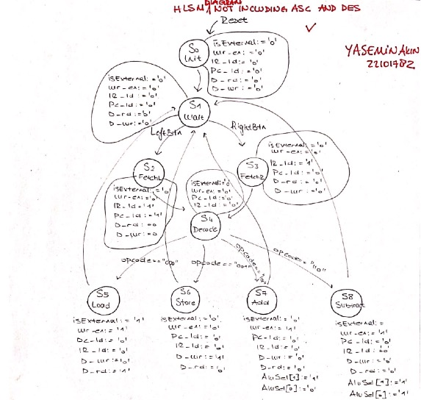

d) Controller Block Diagram

e) Controller/Datapath Top Module Block Diagram

f) Testbenchs

//Testbenches

//control unit testbench:

`timescale 1ns/1ps

module control_Unit_Test();

logic clk, reset, leftBt, rightBt, switchEn; logic [11:0] switch;

logic [3:0] D_addr;

logic D_rd, D_wr;

logic [2:0] RF_addr1;

logic [2:0] RF_addr2;

logic [2:0] RF_waddr;

logic [1:0]ALUSel;

logic isExternal, wr_en;

logic[11:0] IM_ins ;

Control_Unit dut(clk, reset, leftBtn, rightBtn, switchEn, switch, D_addr,

D_rd, D_wr, RF_addr1, RF_addr2, RF_waddr, ALUSel, isExternal, wr_en, IM_ins);

initial

clk = 1;

always begin

#15; clk = ~clk;

end

initial begin

#10; reset = 1;

#10; reset = 0;

#20; leftBtn = 1;

#30; leftBtn = 0;

#20; leftBtn = 1;

#50; leftBtn = 0;

#20; leftBtn = 1;

#30; leftBtn= 0;

#20; leftBtn = 1;

end

endmodule

//simple processor testbench:

`timescale 1ns/1ps

module processor_Test();

logic clk, rightBtn, switchEn, leftBtn, reset; logic [11:0] switch;

logic [11:0]IM; logic [6:0] seg; logic [3:0] an;

logic [3:0] Rel; logic dp;

Simple_Processor dut_sp ( clk, reset, leftBtn, rightBtn, switchEn, switch,seg, dp, an, Rel, IM );

initial

clk = 1;

always begin

#1; clk = ~clk;

end

initial begin

#10; reset = 1;

#15; reset = 0;

#20; leftBtn = 1;

#25; leftBtn = 0;

#20; leftBtn = 1;

#30; leftBtn = 0;

#30; leftBtn = 1;

#40; leftBtn = 0;

#35; leftBtn = 1;

end

endmodule